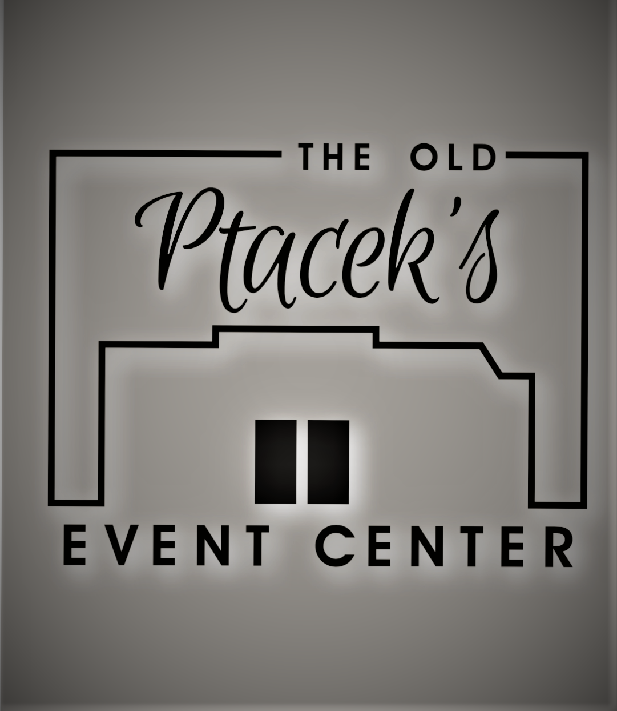

The Old Ptacek’s Catering Menu

Lasagna Dinner…$16.95

Lasagna

French Bread or Rolls

Tossed Salad

Coffee and Milk

Italian Buffet…$ 19.99

Choose either chicken marsala or garlic roasted chicken.

Meatballs

Pasta, marinara and alfredo

Tossed salad

Garlic bread

Coffee and milk

Prime Rib……$49.99

Prime rib

Choice of Potato

Tossed salad or Coleslaw

French Bread or Rolls

Milk and Coffee

Condiments

Grill Out….$17.00

Choice of two meats:

Hamburgers, Hot Dogs, Brats

Choice of two salads:

Baked Beans, Potato Salad, Coleslaw, Pasta Salad

Cookies and chips

Condiments

Chicken &/ or Pork Chops

$17.50for one meat/$19.99for both meats

Grilled chicken, or pork chops

Choose two sides:

Au Gratin Potatoes, Scalloped Potatoes, Baked Potatoes, Baked Beans, Potato Salad, Pasta Salad, Lettuce Salad, Chinese Coleslaw

Rolls

Condiments

Milk and coffee

Buffet Style Dinner….$19.99

Choose Two meats:

Beef, Pork, Turkey, Ham, Baked or Grilled Chicken

Choice of Potato:

Baked, Mashed, Scalloped, Au gratin

Bread Dressing

Choose Two Sides:

Corn, Beans, Baked Beans, Pasta Salad, Coleslaw, Lettuce Salad, Creamy Fruit Salad, Pistachio Salad,

Chinese Coleslaw.

Relishes

Rolls

Condiments, Milk, Coffee, Punch

We are able to accommodate food allergies, just let us be aware of them ahead of time.

We are able to customize any menu to your personal taste.

If wanting to use glass plates and metal silverware, $2.00 per person will be added per plate.

We do not include an automatic gratuity.
It is completely up to you with your satisfaction of our service

All meals are served buffet style.

Tax of 5.5% will be added to your bill

Ask for Katie
Deposit Required to save Day
715-262-5636 (W)
katp@centurytel.net

