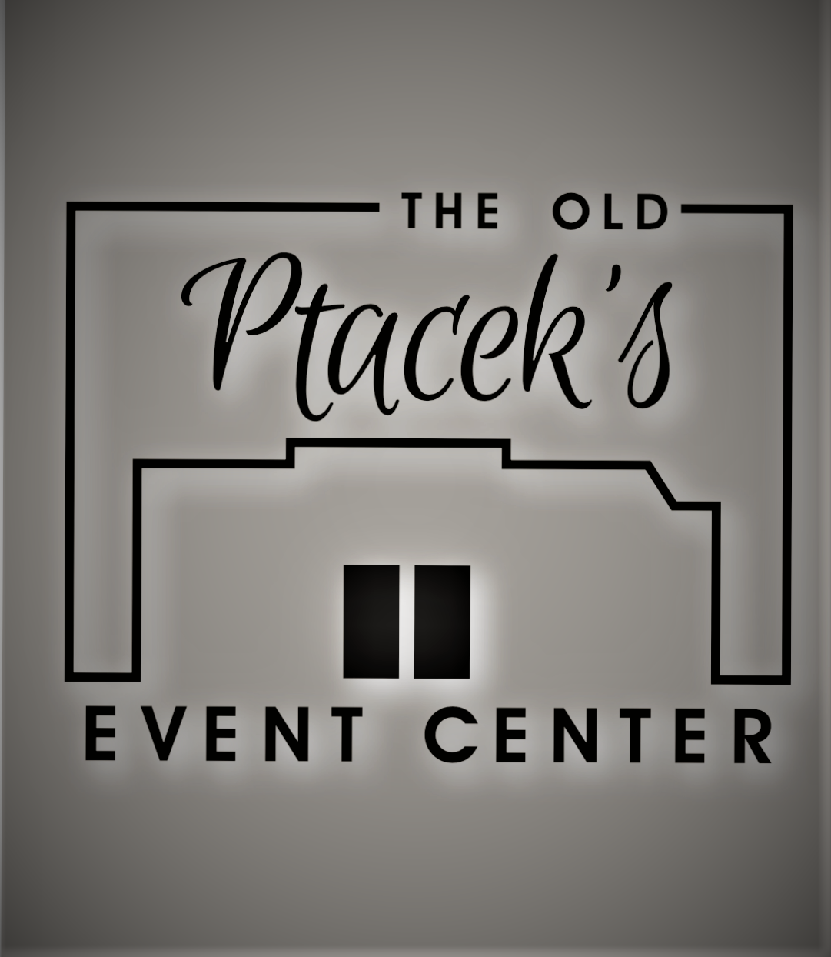
The Old Ptacek’s Catering Menu

Lasagna Dinner…$16.95
Lasagna
French Bread or Rolls
Tossed Salad
Coffee and Milk

Italian Buffet…$ 18.95
Choose either chicken marsala or garlic roasted chicken.
Meatballs
Pasta, marinara and alfredo
Tossed salad
Garlic bread
Coffee and milk

Prime Rib……$34.95
Prime rib
Choice of Potato
Tossed salad or Coleslaw
French Bread or Rolls
Milk and Coffee
Condiments

Grill Out….$14.95
Choice of two meats:
Hamburgers, Hot Dogs, Brats
Choice of two salads:
Baked Beans, Potato Salad, Coleslaw, Pasta Salad
Cookies and chips
Condiments

Chicken &/ or Pork Chops
$16.50for one meat/$18.50for both meats
Grilled chicken, or pork chops
Choose two sides:
Au Gratin Potatoes, Scalloped Potatoes, Baked Potatoes, Baked Beans, Potato Salad, Pasta Salad, Lettuce Salad, Chinese Coleslaw
Rolls
Condiments
Milk and coffee

Buffet Style Dinner….$18.00
Choose Two meats:
Beef, Pork, Turkey, Ham, Baked or Grilled Chicken
Choice of Potato:
Baked, Mashed, Scalloped, Au gratin
Bread Dressing
Choose Two Sides:
Corn, Beans, Baked Beans, Pasta Salad, Coleslaw, Lettuce Salad, Creamy Fruit Salad, Pistachio Salad,
Chinese Coleslaw.
Relishes
Rolls
Condiments, Milk, Coffee, Punch

We are able to accommodate food allergies, just let us be aware of them ahead of time.

We are able to customize any menu to your personal taste.

If wanting to use glass plates and metal silverware, $2.00 per person will be added per plate.

We do not include an automatic gratuity.
It is completely up to you with your satisfaction of our service

All meals are served buffet style.

Tax of 5.5% will be added to your bill

Ask for Katie
Deposit Required to save Day
715-262-5636 (W)
katp@centurytel.net

